Practical 1

Question 1:

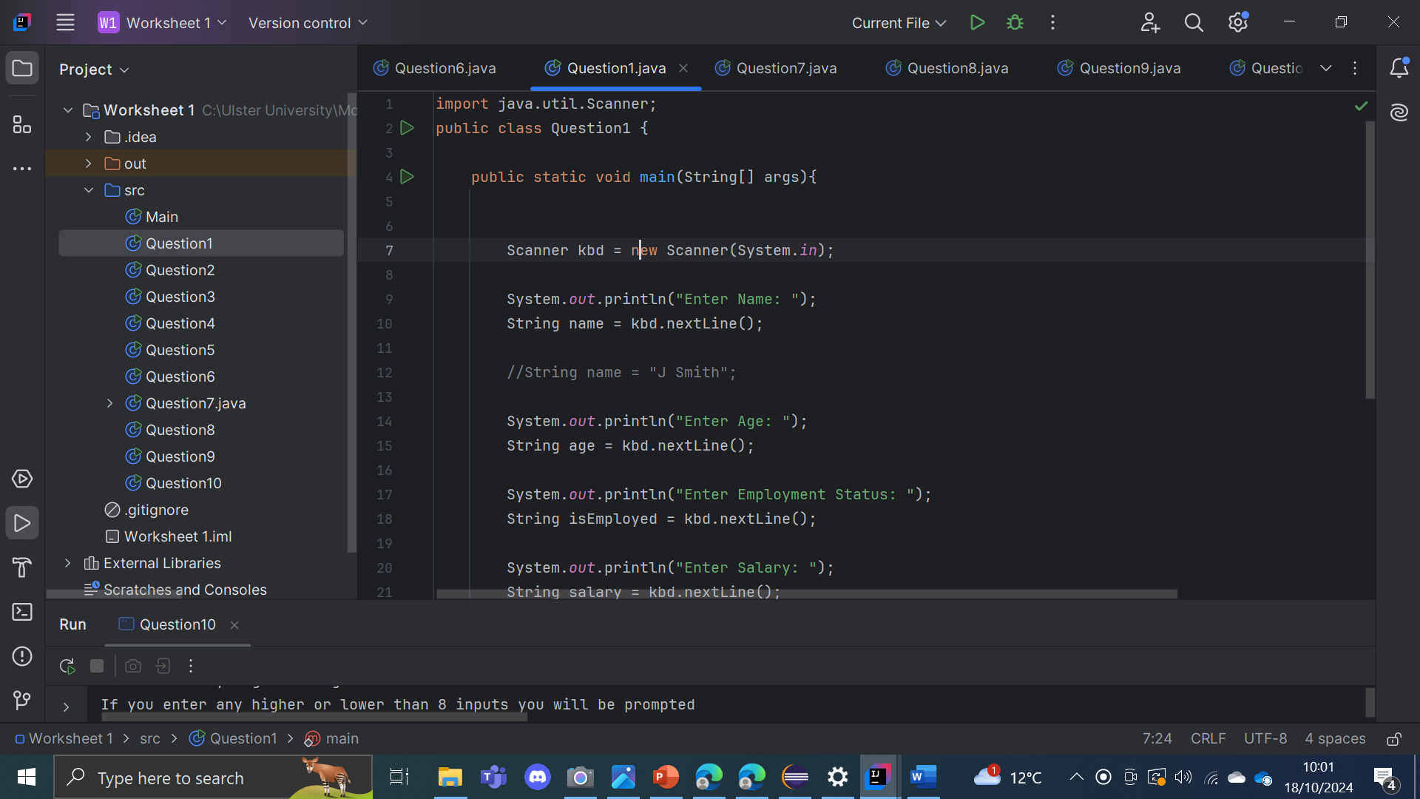

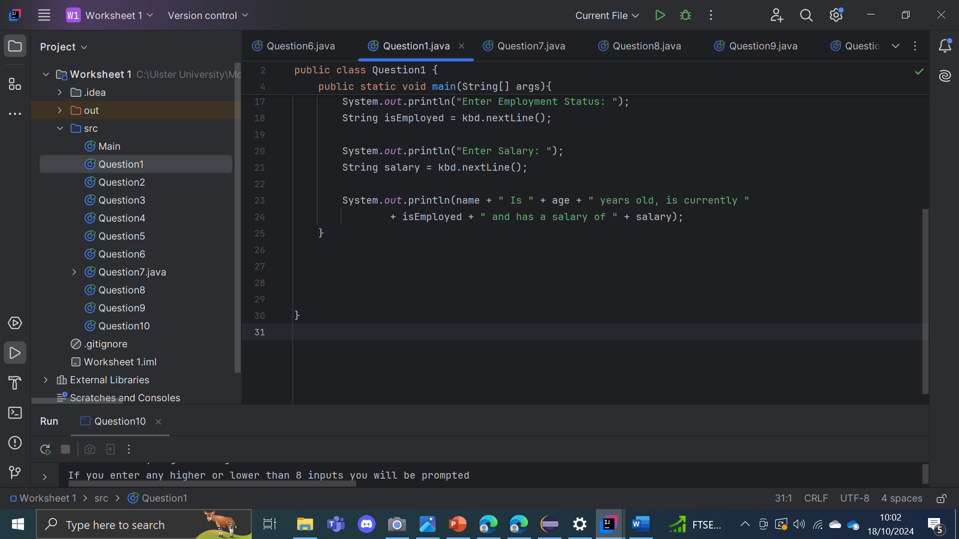

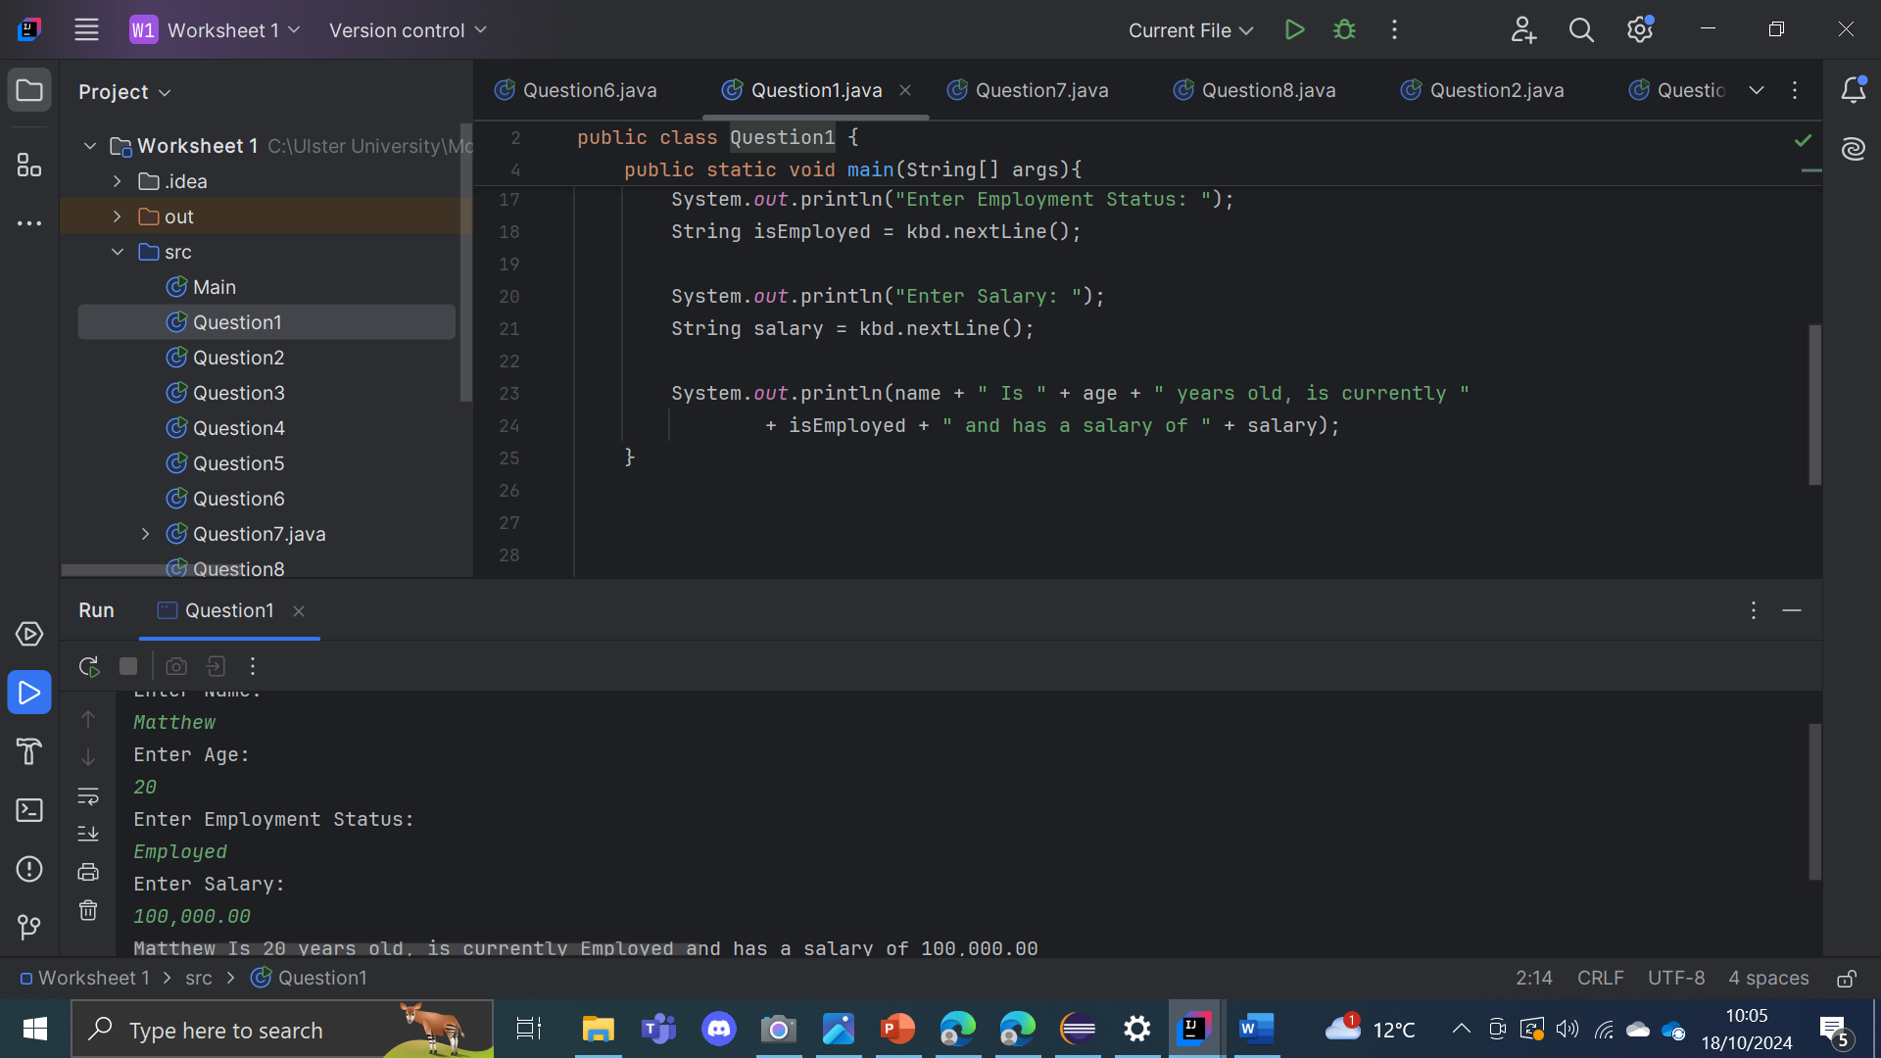

This program gets the user input using the Scanner to get details such as the user’s name, age, employment status, and salary. After prompting the user for each of these inputs, the program stores them as strings. It then prints a summary sentence that combines the user's input into statement, stating the name, age, employment status, and salary. The program uses System.out.println() to display the output.

Question 2:

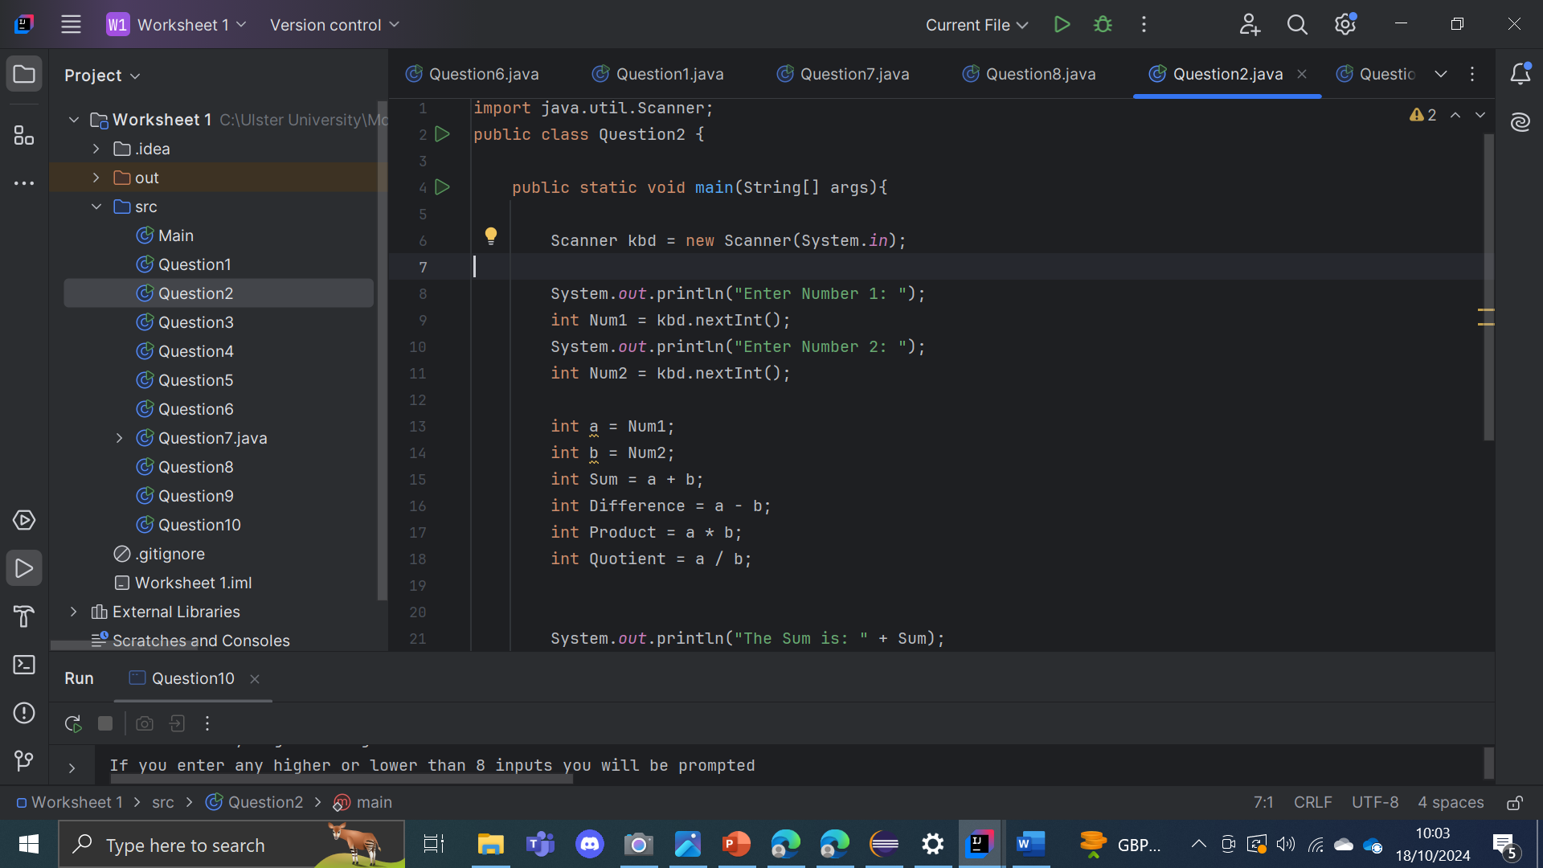

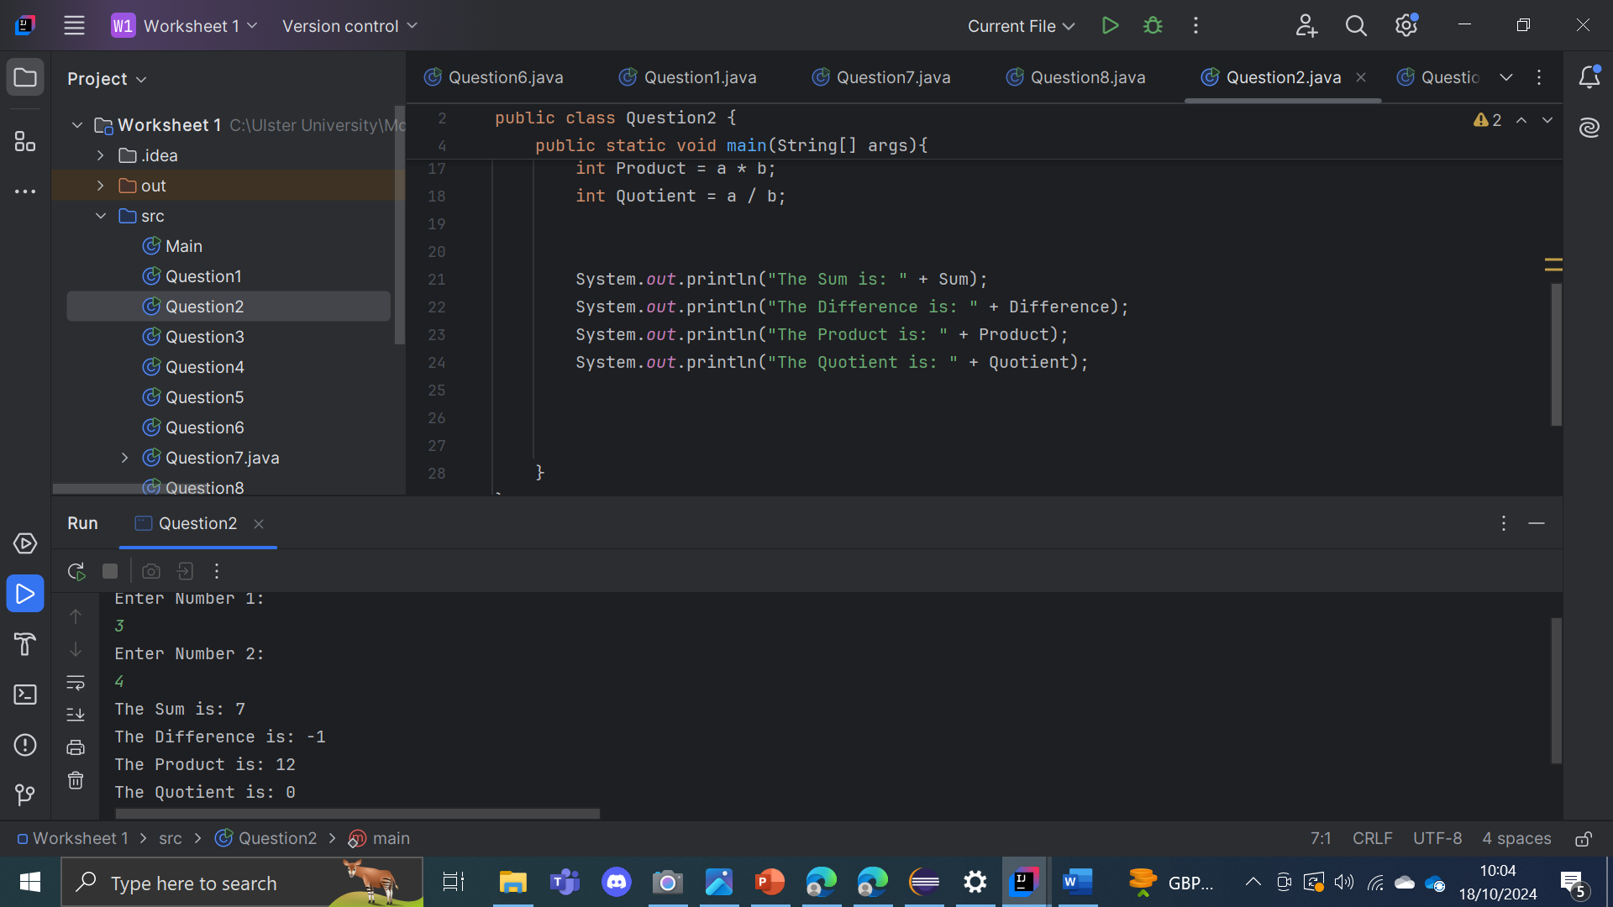

This program gets the user to input two numbers and then performs four basic maths such as addition, subtraction, multiplication, and division. After asking the user for the two numbers, the program stores the numbers within Num1 and Num2, which are then assigned to variables a and b. It calculates the sum, difference, product, and quotient of the two numbers and stores the results. The results are then printed using System.out.println(); The program is coded so when dividing by zero would cause an error.

Question 3:

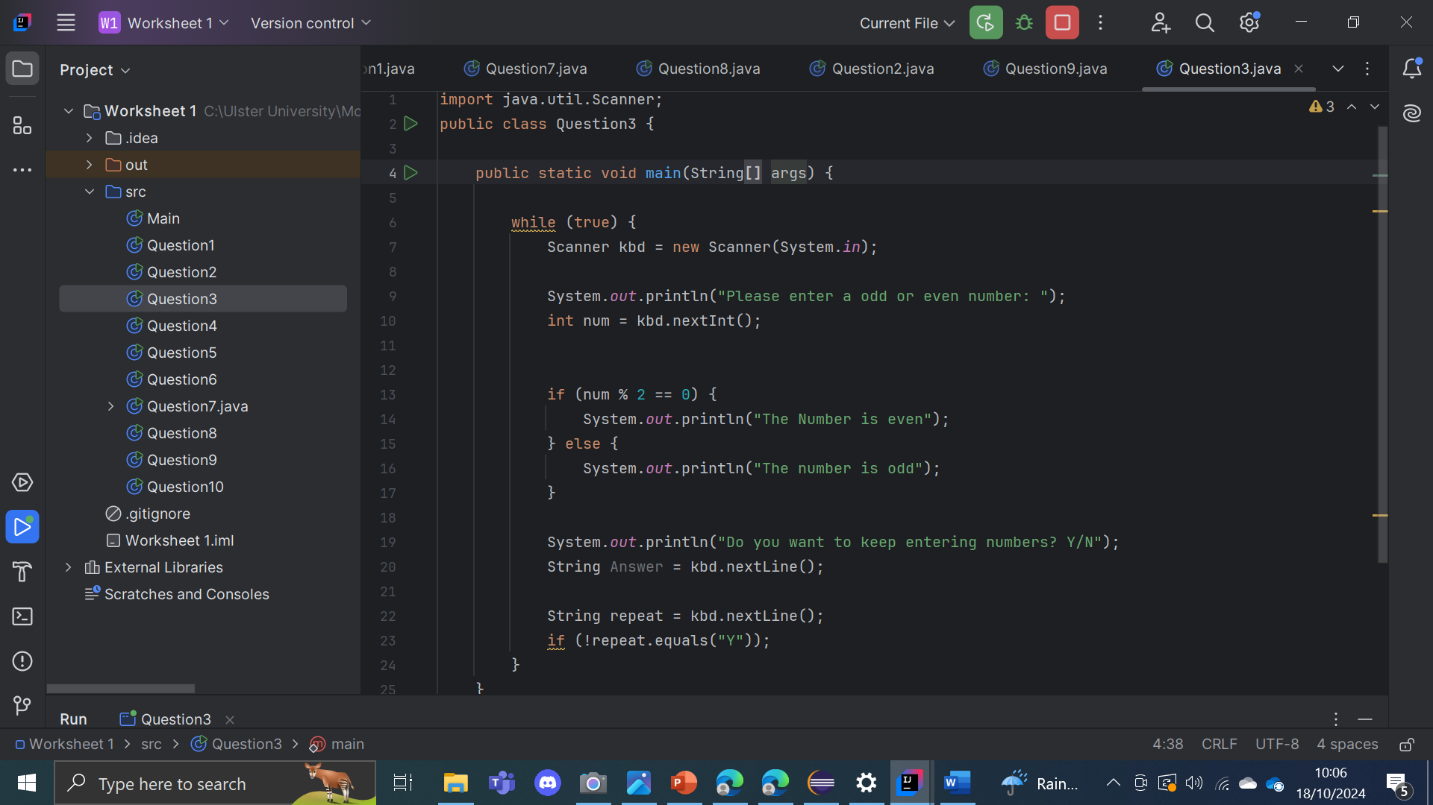

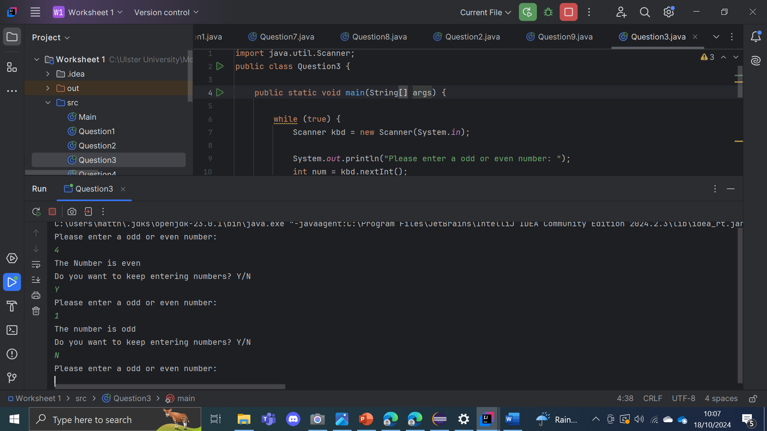

This program repeatedly asks the user to enter a number and checks whether the number entered is odd or even using the modulus operator %. And by using an IF statement the program checks if the number is divisible by 2, it is counted as even otherwise it is counted as odd. After displaying the result, the program asks the user if they want to continue entering numbers by prompting for a "Y" or "N".

Question 4:

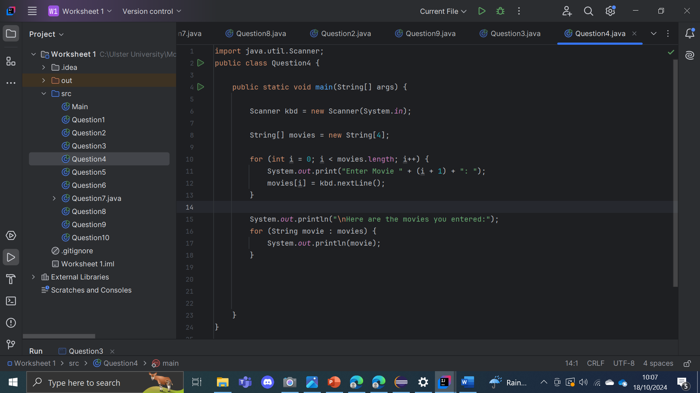

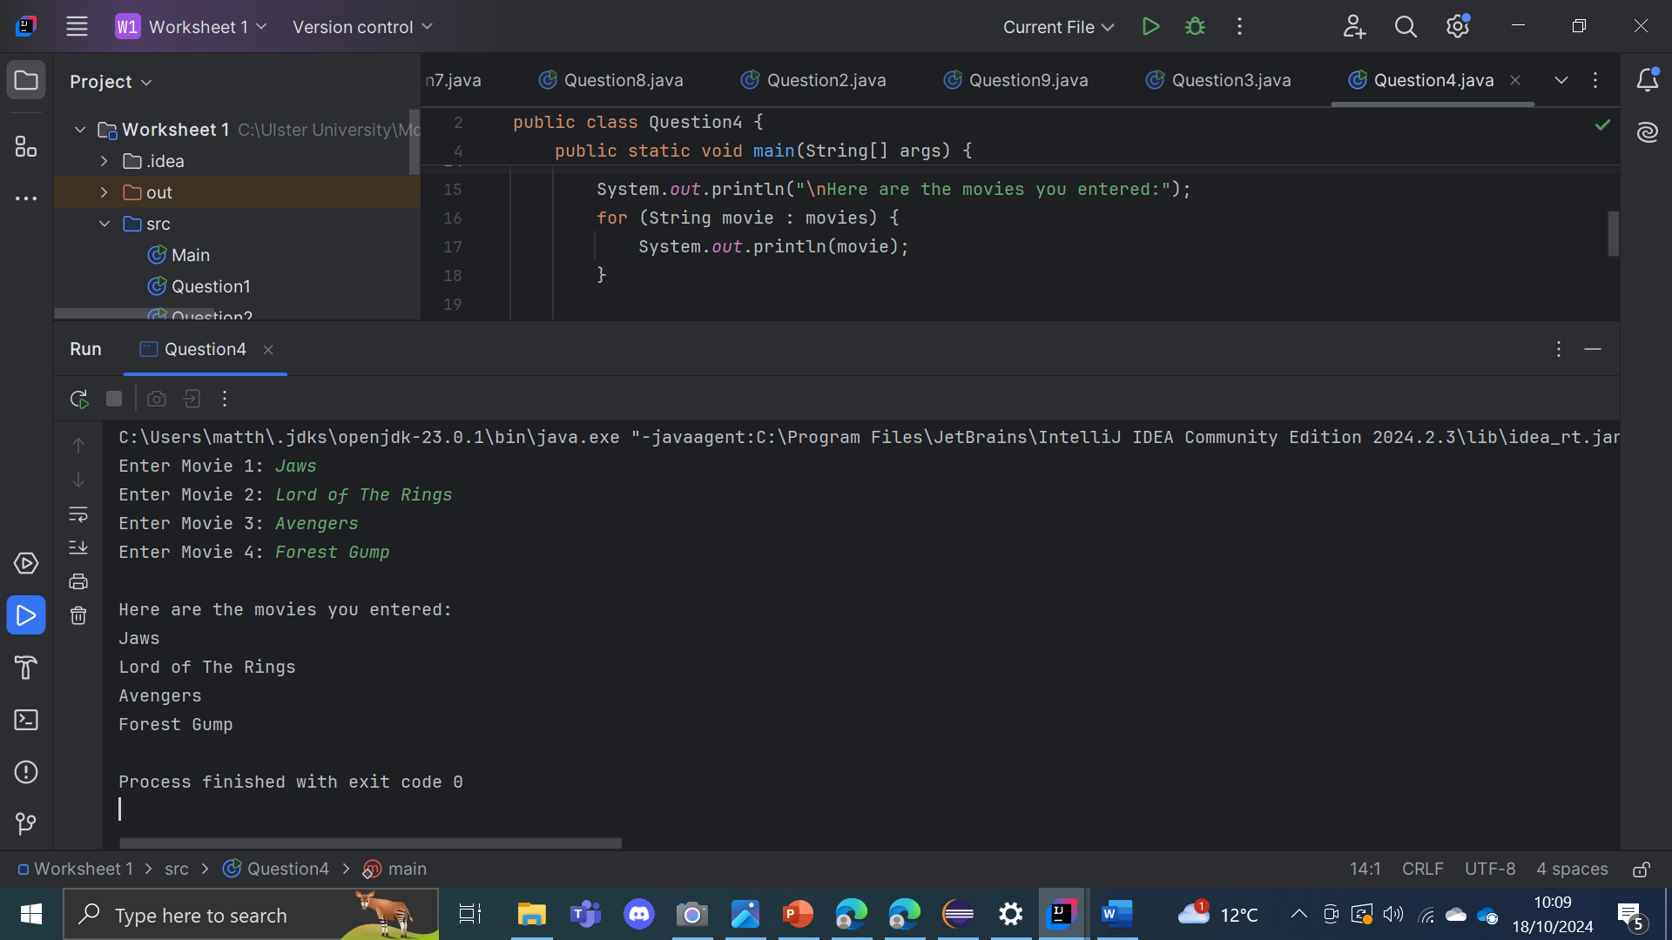

This program asks the user to enter four movies and then stores them in an array. It uses a for loop to go through the array, asking the user to input a movie name one at a time, which is then stored in the corresponding position in the array. After all movie names are entered, the program prints a list of the movies using a for loop to display each movie on separate lines. The program in short allows the user to input exactly four movie titles, which are then output in the order they were entered.

Question 5:





This program prompts the user to input two integers and then performs four operations: addition, subtraction, multiplication, and division. It stores the results of these operations in separate variables. After calculating these values, the program prints the results of each operation with descriptive messages. The division operation assumes the second number is not zero, as dividing by zero would result in an error. The program outputs the computed sum, difference, product, and quotient based on the user's input.

Question 6:

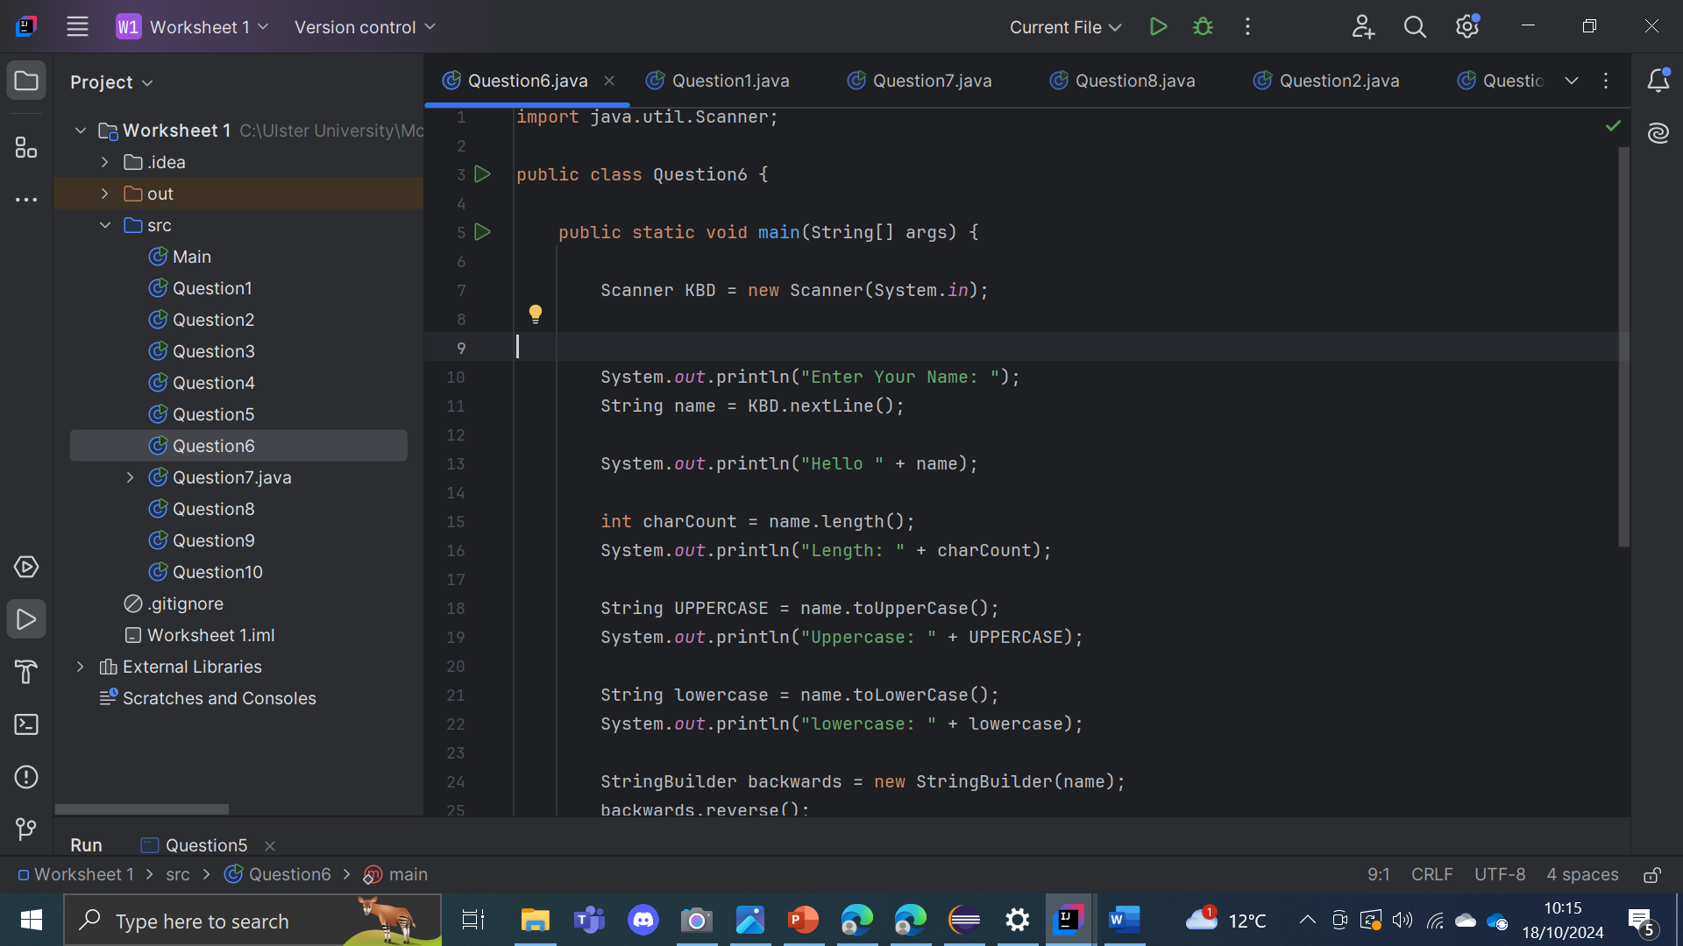

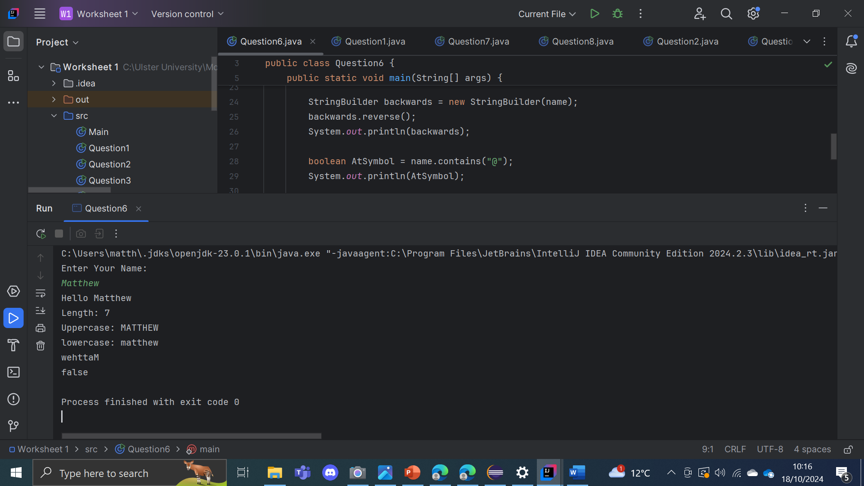

The program asks the user to enter their name and then performs a series of operations. It greets the user with a personalized message and calculates the length of the name, displaying the character count. The program also converts the name to uppercase and lowercase printing both. It also makes the name go in reverse using StringBuilder and displays the reversed string. It also scans whether the name contains an "@" symbol, outputting the result as a Boolean value true or false.

Question 7:

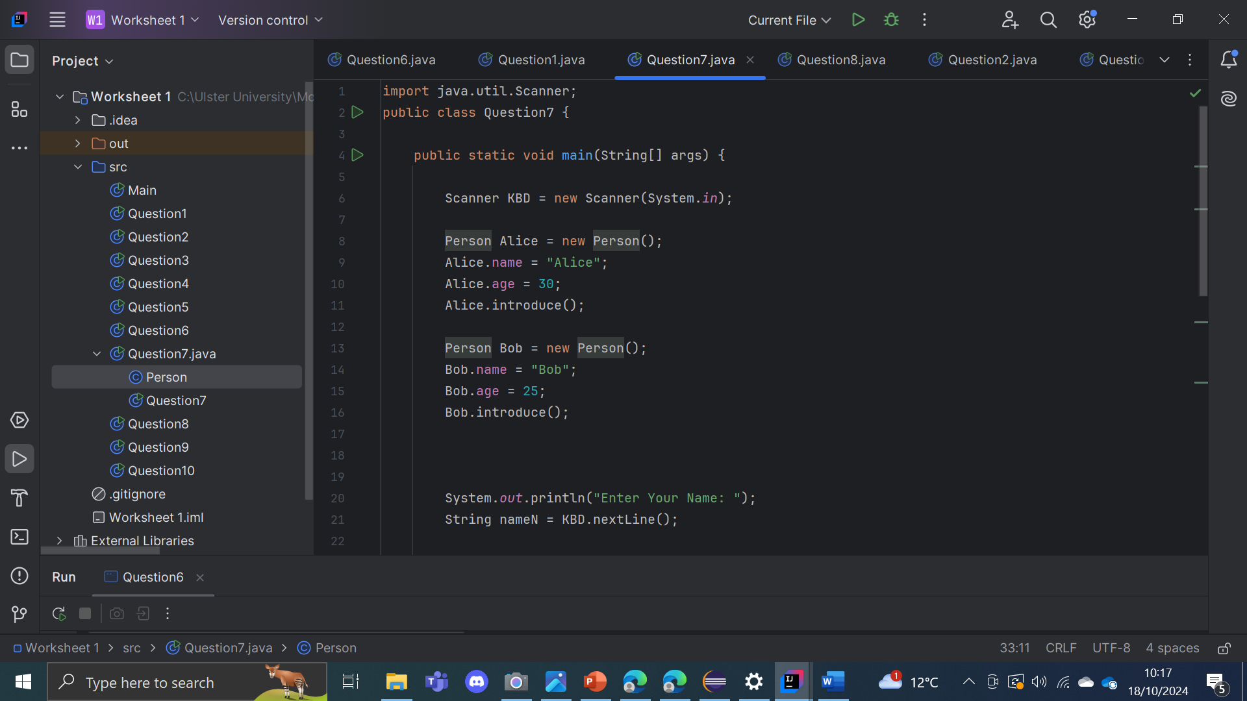

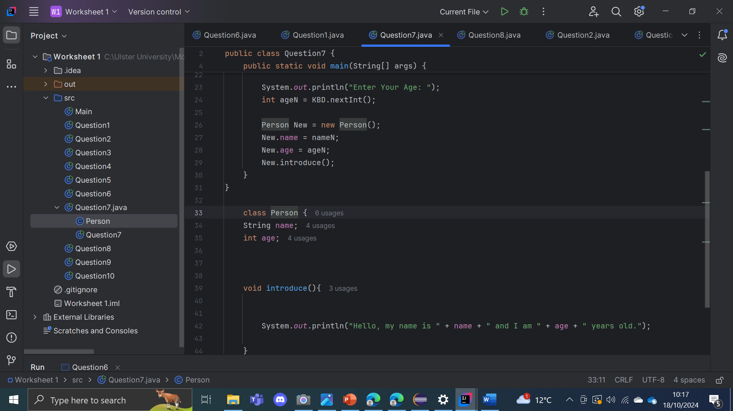

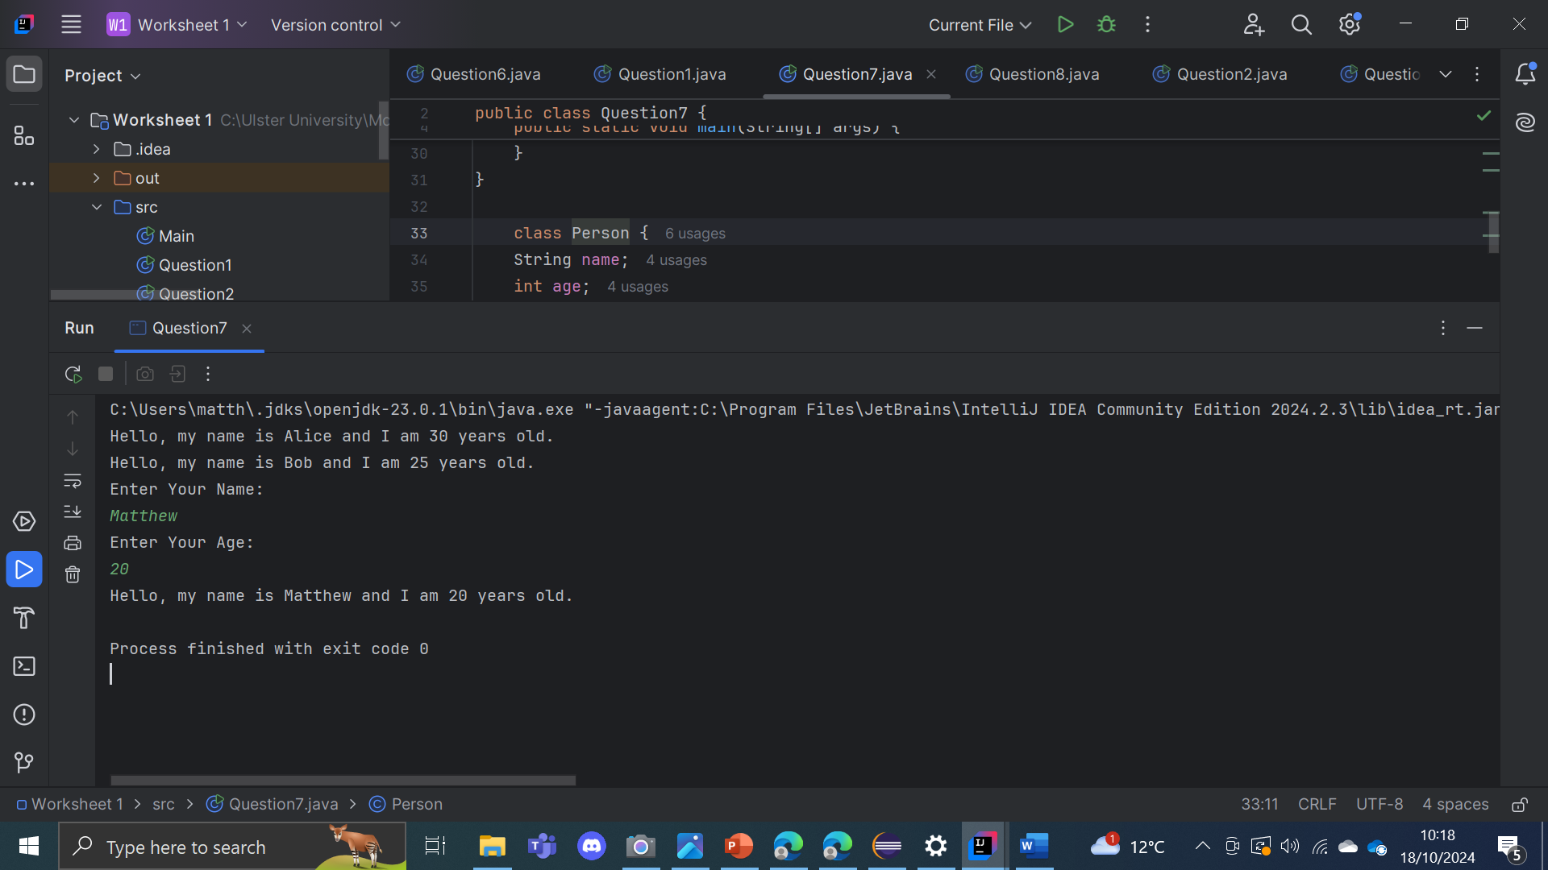

This program uses a Person class with attributes for a person's name and age, along with a method called introduce() that outputs a greeting message including the person's name and age. In the main, the program creates two predefined Person objects: Alice, who is 30 years old, and Bob, who is 25. Both of these people use introduce() to display their details. The program then asks the user to input their own name and age, creates a new Person object using the provided data, and calls the introduce() method for that object as well which results in the new person being printed.

Question 8:

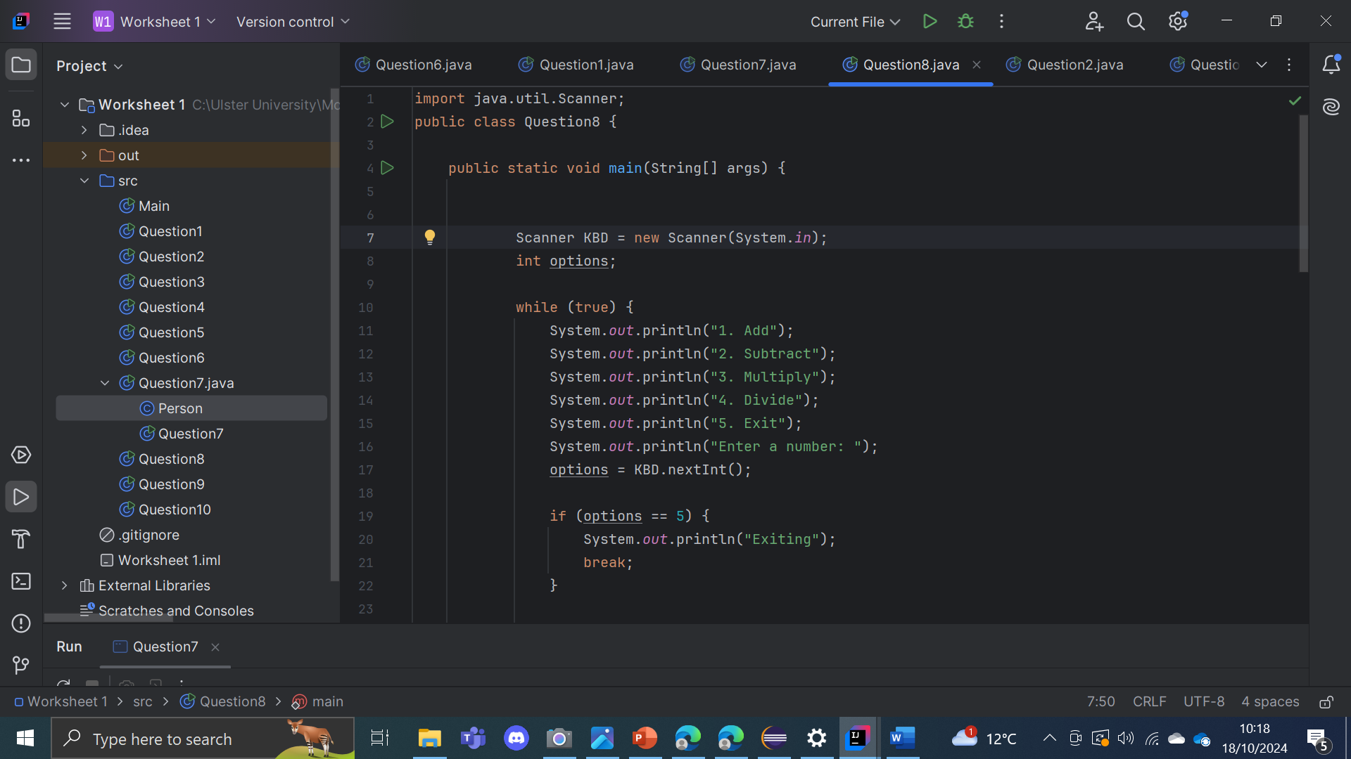

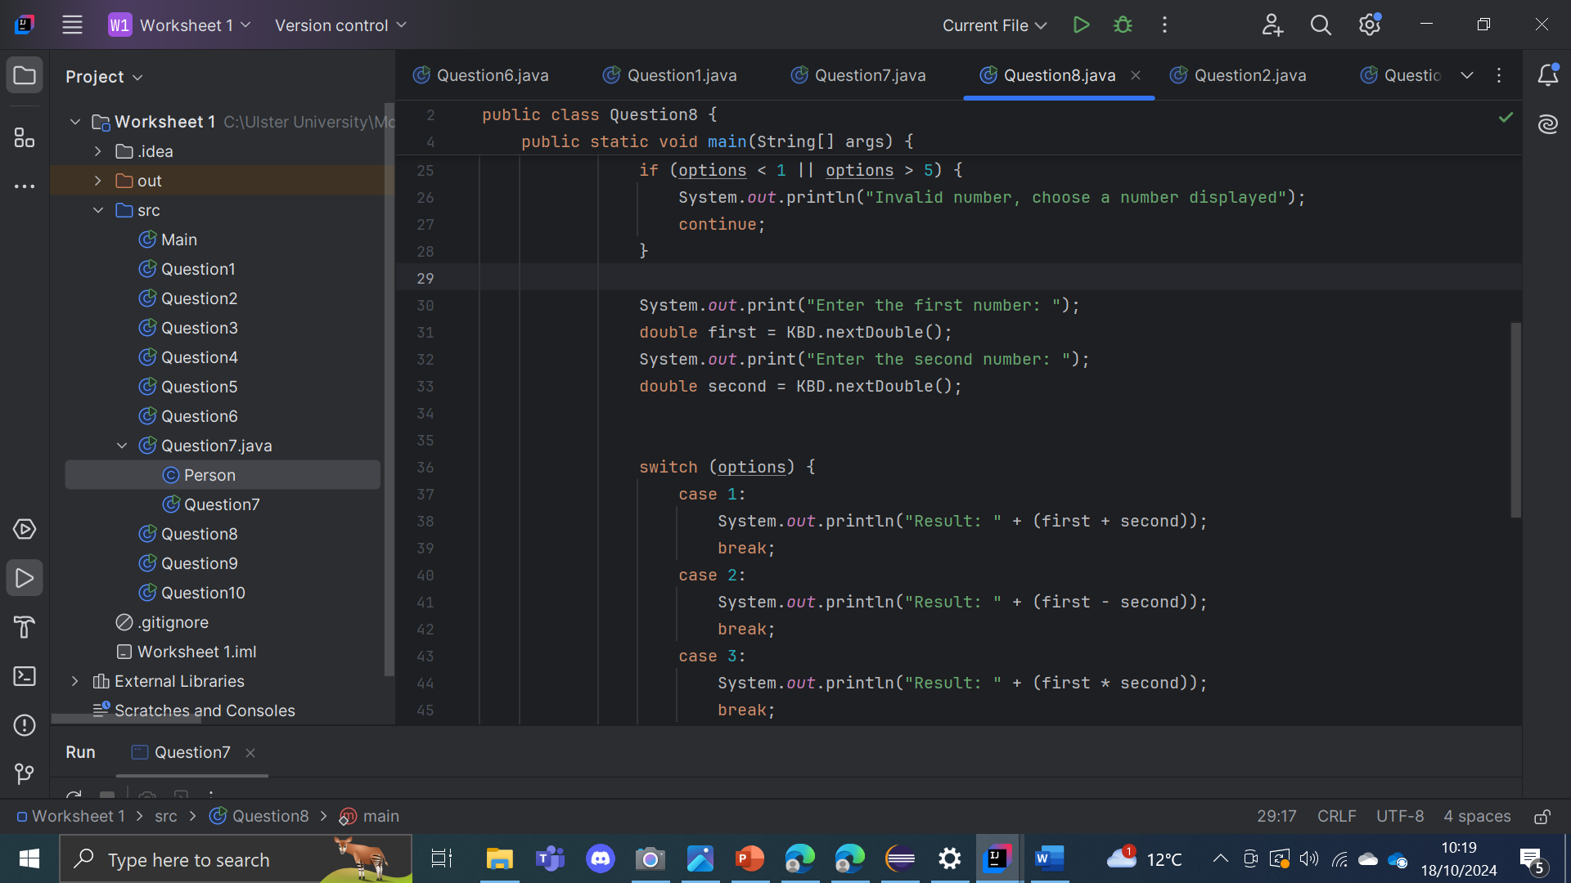

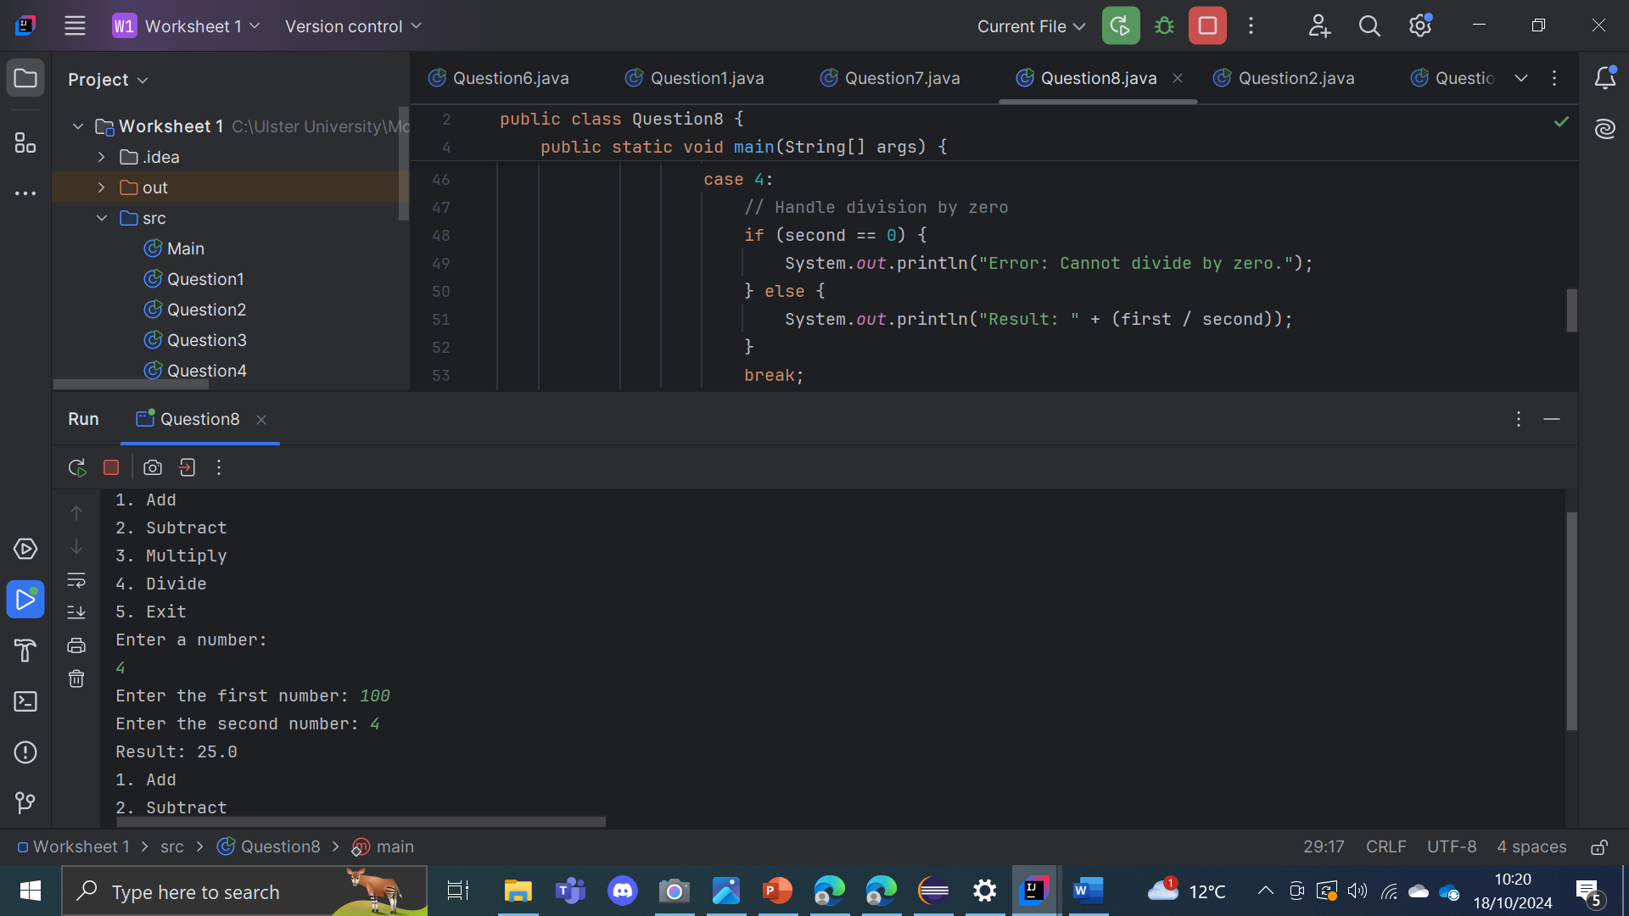

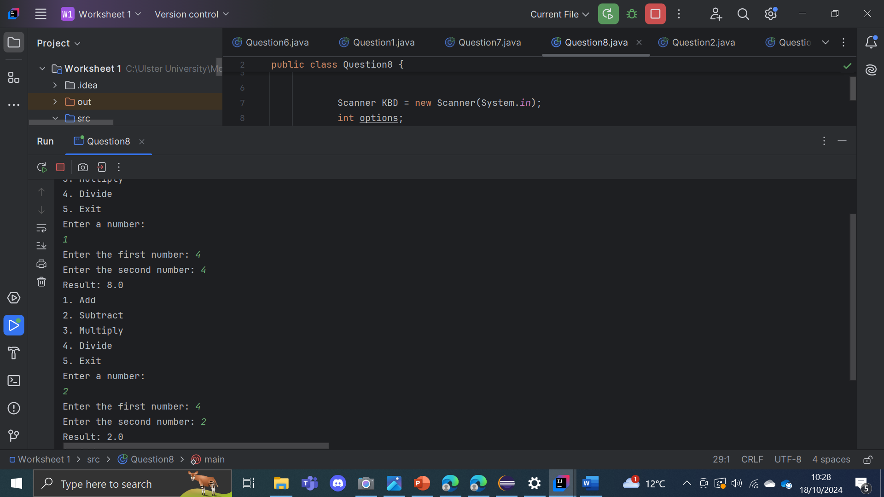

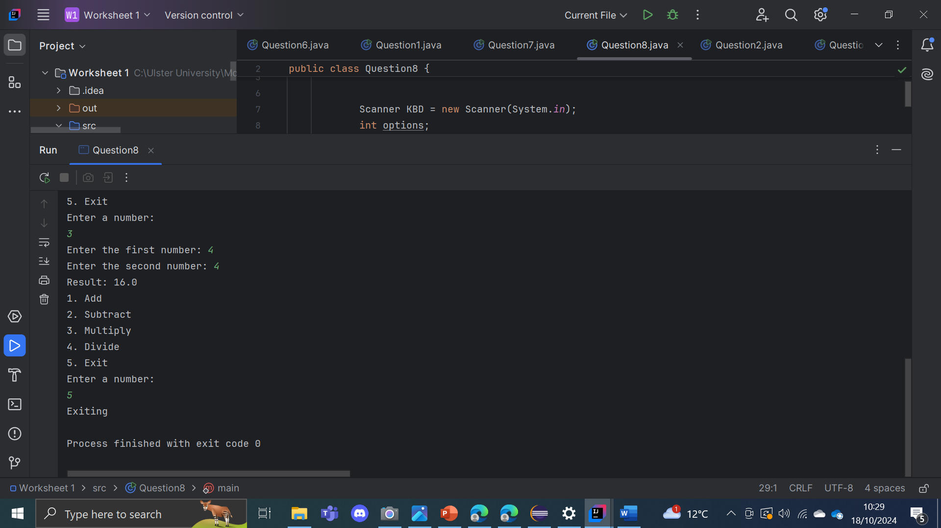

This program uses a simple calculator function that allows users to perform basic arithmetic operations: addition, subtraction, multiplication, and division. The user is asked to select an operation by entering a number corresponding to the menu options. If the user selects an invalid option less than 1 or greater than 5, the program has an error message and then repeats the code. To have the system run normally the program asks for two numbers and performs the selected calculation operation, displaying the result. It also includes validation for division by zero, so the program does not crash if the user attempts to divide by zero. The program will stop when the user chooses 5.

Question 9:

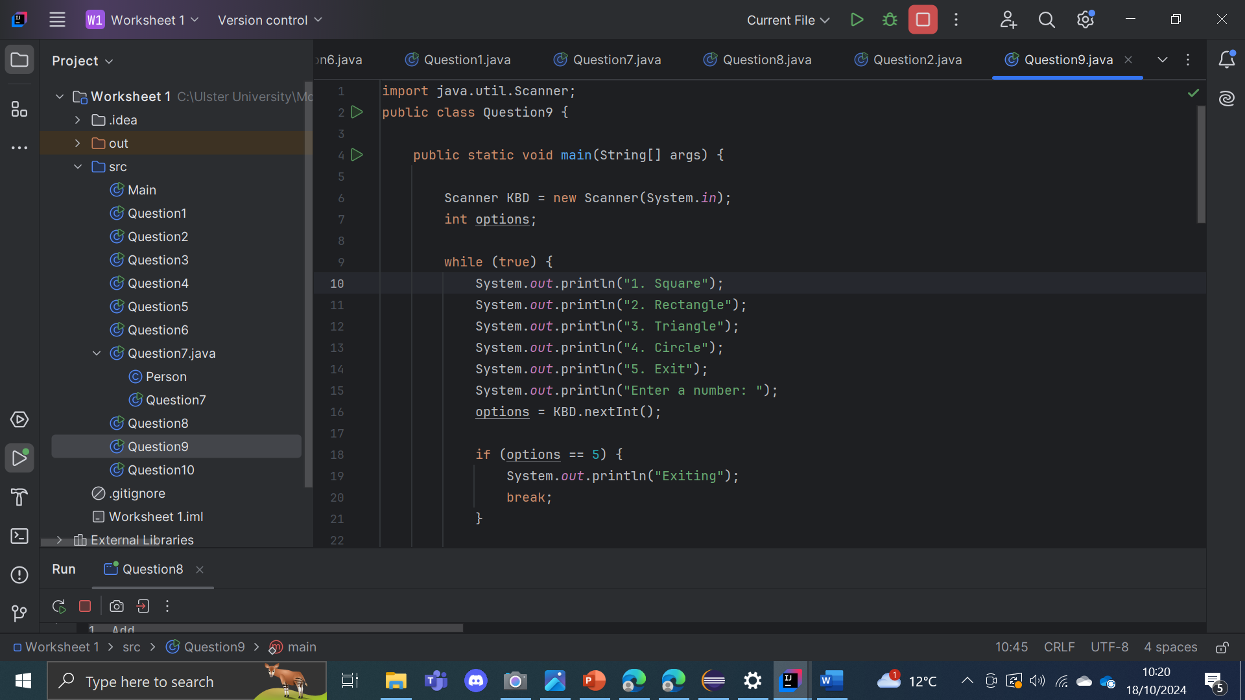

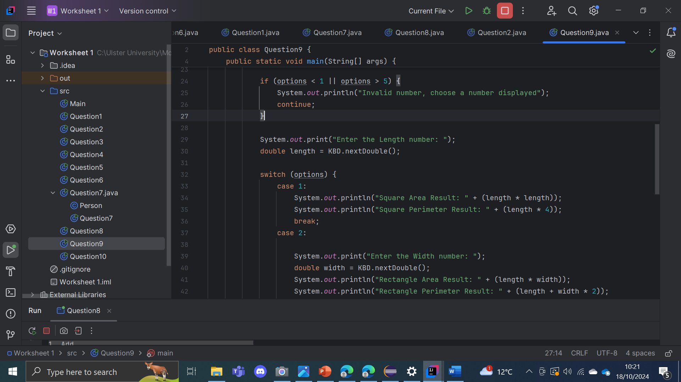

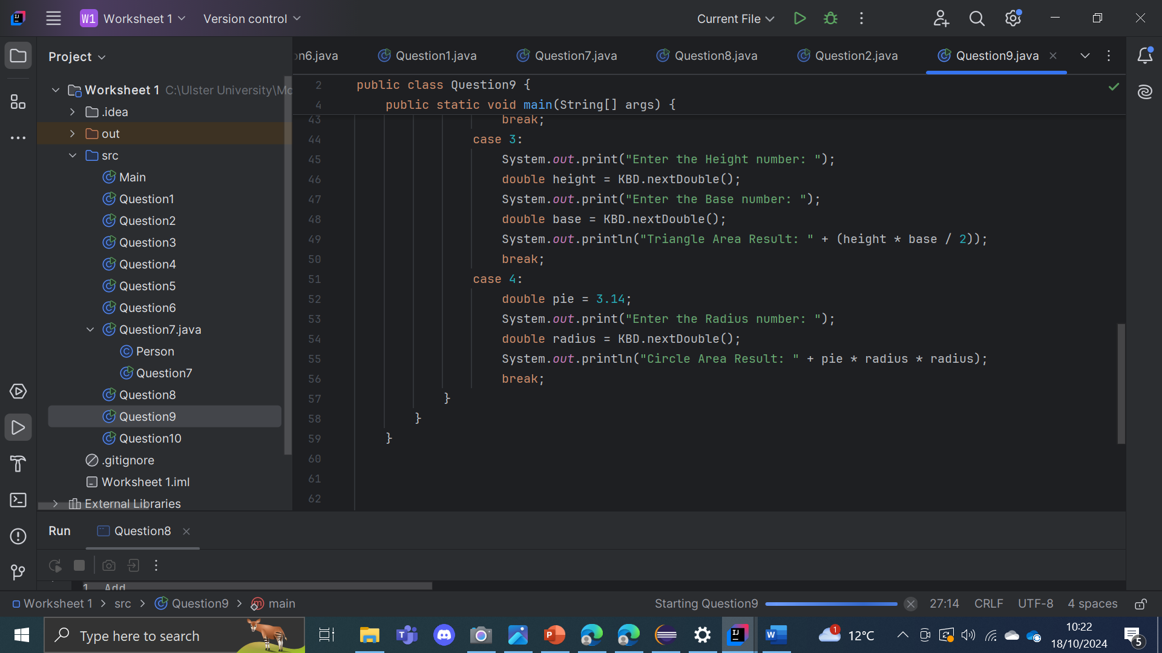

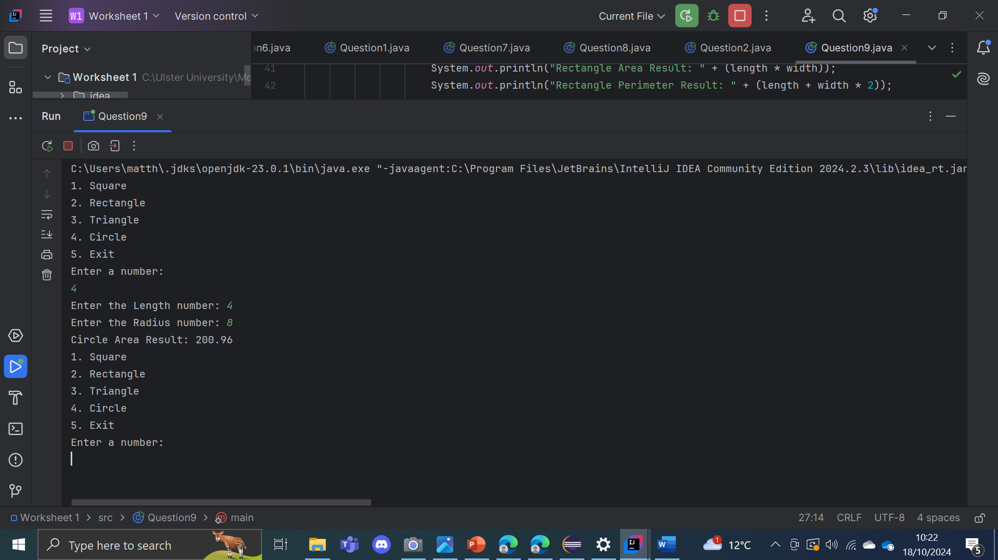

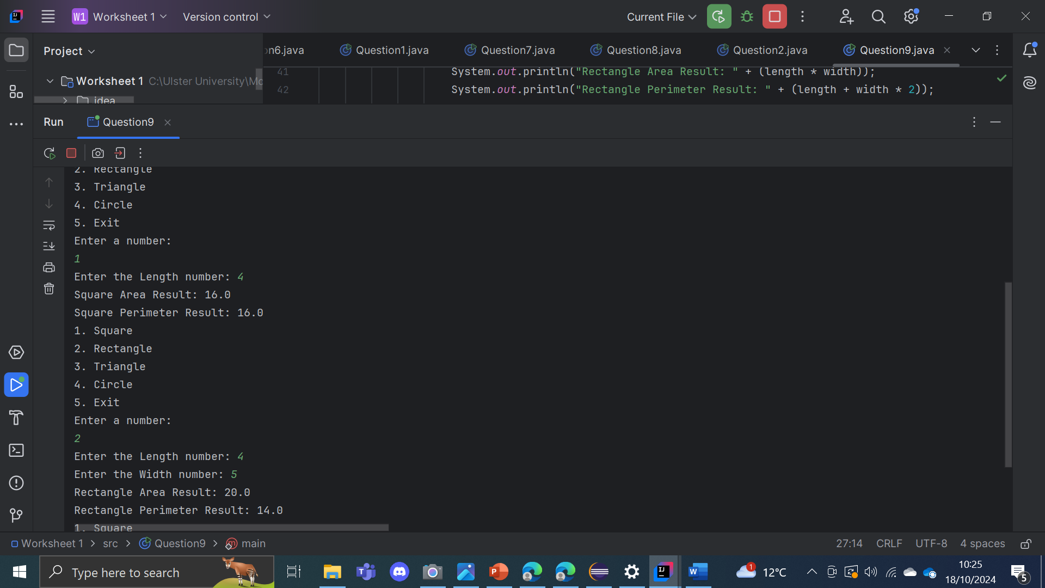

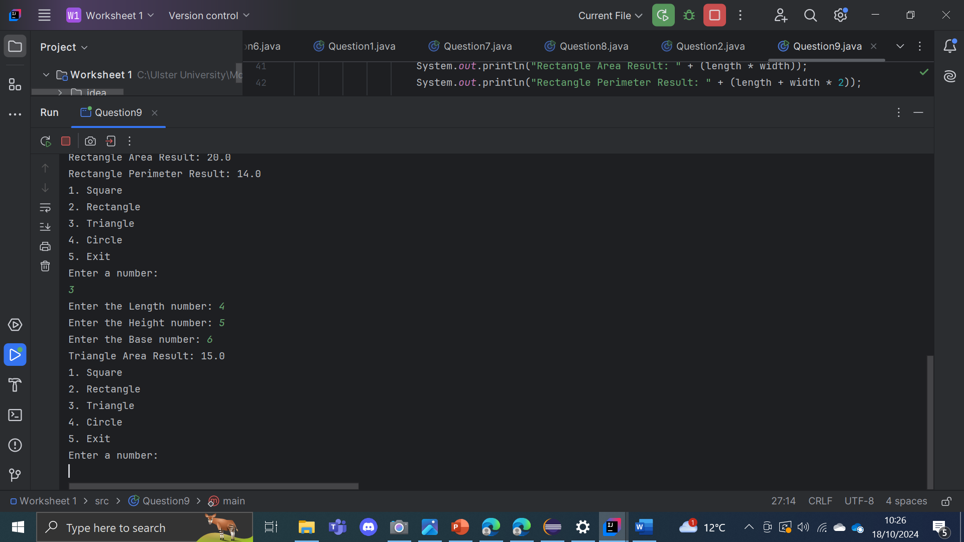

This program serves as a calculator that allows users to compute the area and perimeter of various shapes, including squares, rectangles, triangles, and circles. Users can select a shape by entering the corresponding number. For squares, the user is prompted for the length of a side; for rectangles, both length and width are required; for triangles, the user must provide height and base and for circles, the radius is requested. After gathering the necessary dimensions, the program calculates and displays the details for the selected shape. The program continues to loop itself allowing for the users to perform multiple calculations until they choose to exit by entering option 5.

Question 10:

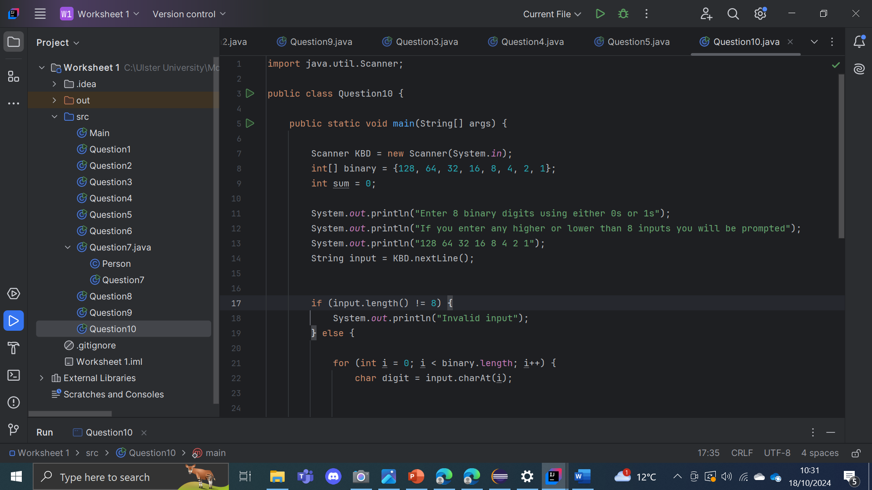

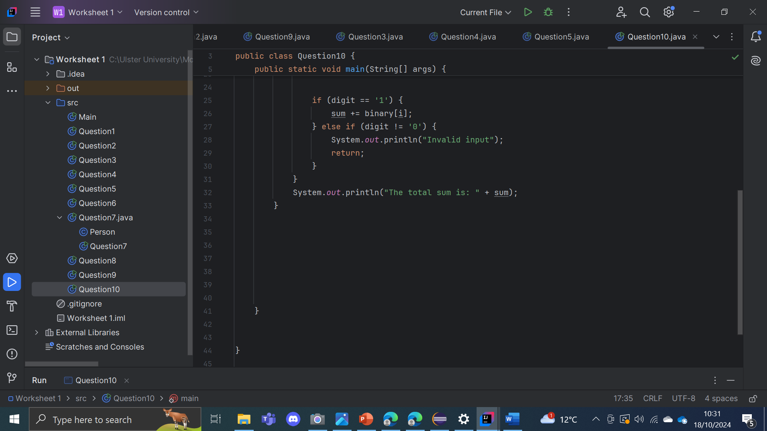

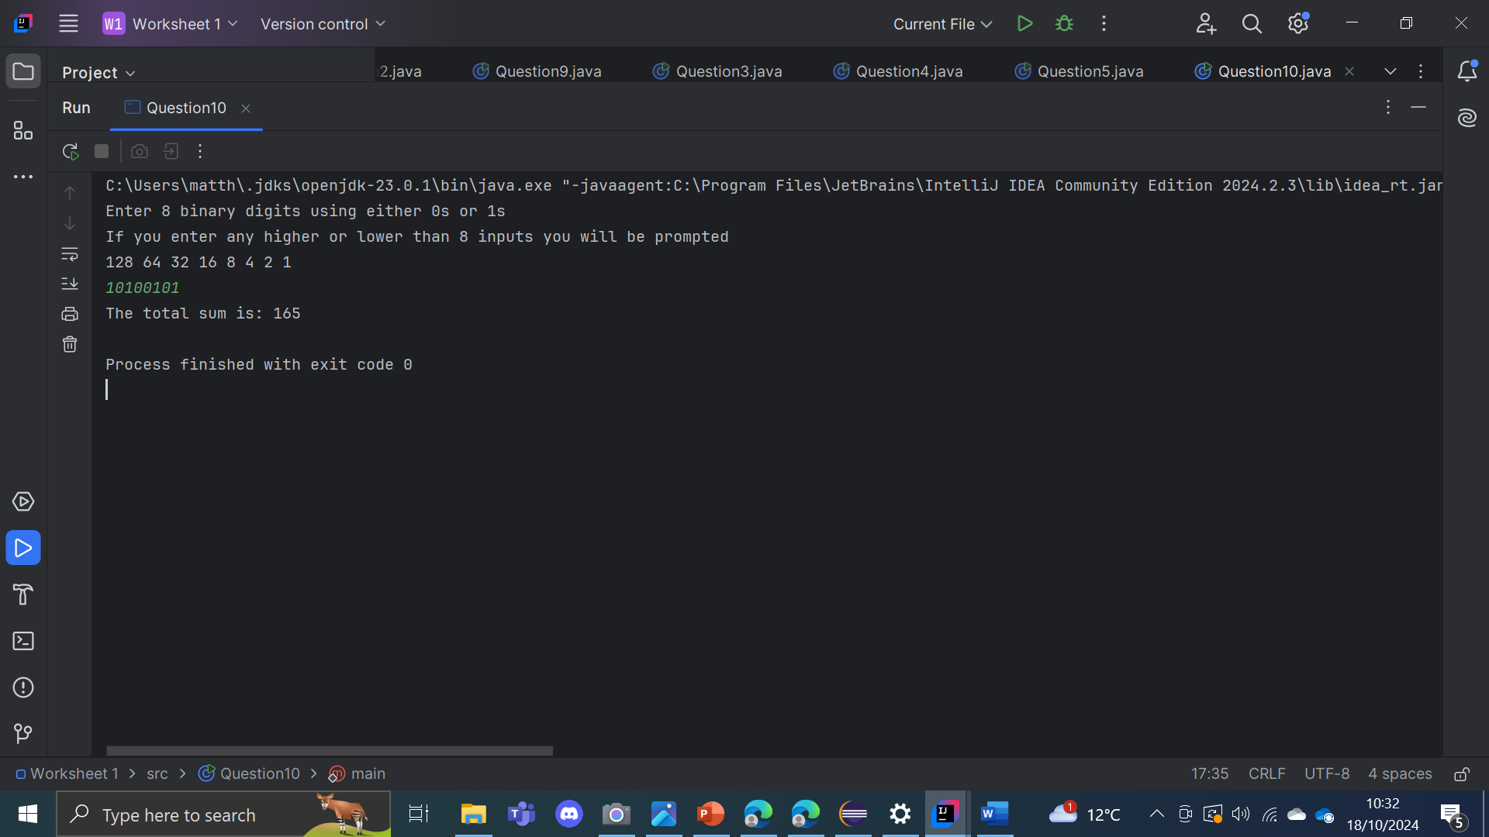

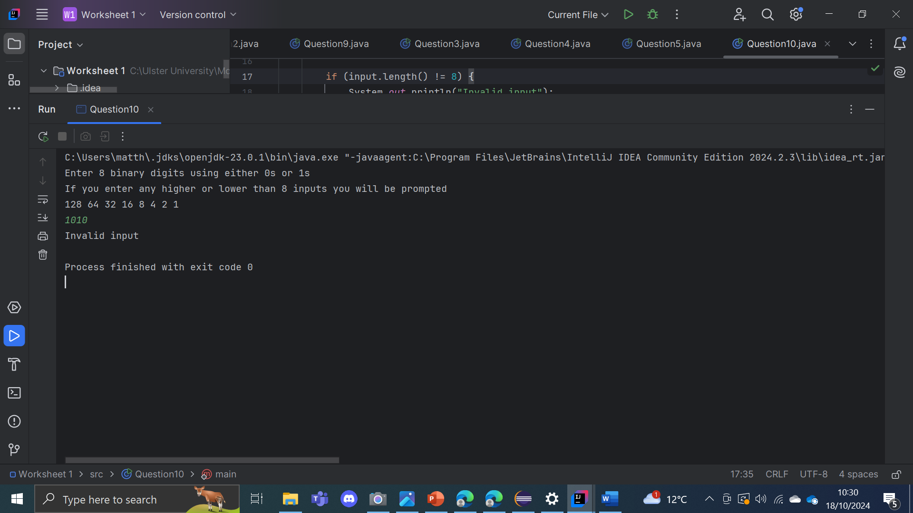

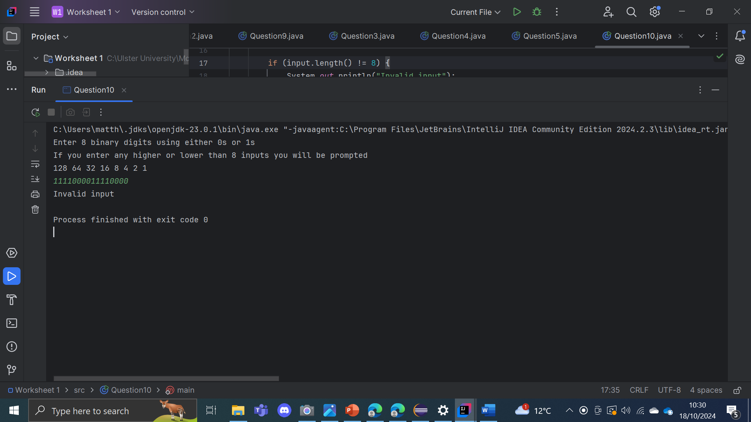

This system asks the user to enter an 8-digit binary number converting it into its decimal equivalent. It uses an array containing the decimal values associated with each binary position: 128, 64, 32, 16, 8, 4, 2, and 1. The program first checks if the input string is exactly 8 characters long; if not, it displays an error message. For a valid input it goes through each character of the string, adding the corresponding decimal value to a total sum if the character is 1.